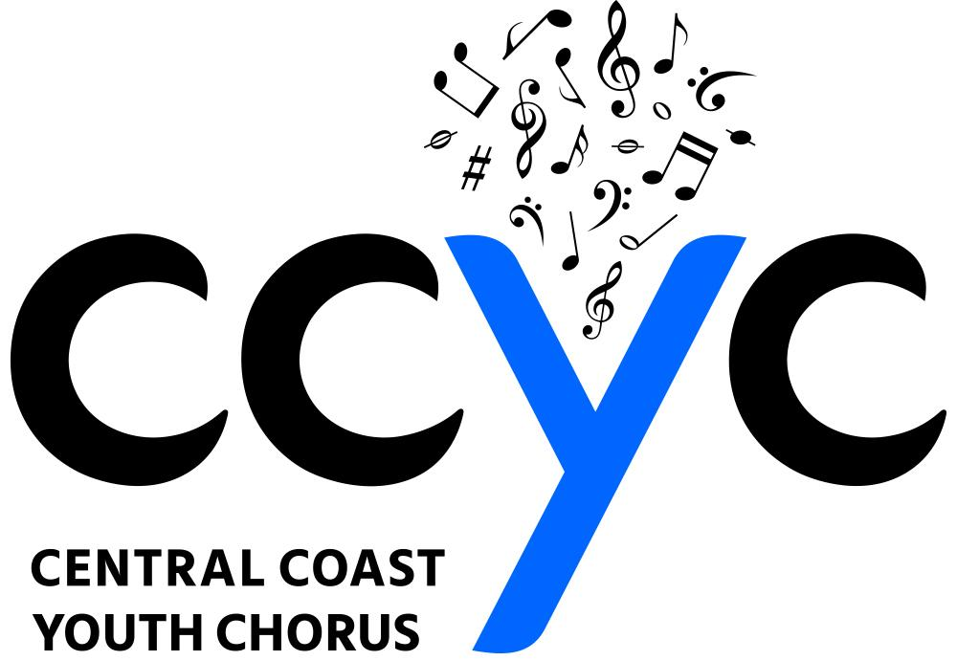

WARDROBE AGREEMENT
2018 - 2019 Season

** Please return this document with your CCYC registration packet **

Student’s Last Name___________________________Student’s First Name

CHOIR LEVEL: Brio Cadence Vivace/AVE YME

(please check one)

- Brio - Blouse, short black skirt (replacement cost: $30 blouse, $30 skirt)

- Cadence/Cadenza - Blouse, short black skirt (replacement cost: $30 blouse, $30 skirt)

- Vivace/AVE - Long black dress (replacement cost: $70)

- Young Men’s Ensemble / Boys - YME - Grey Dress Shirt, Tie (replacement cost: $75)
Boys - White tuxedo shirt, suspenders, black tie (replacement cost: $50)

I, the undersigned, acknowledge and verify that:

- Items indicated above will be received in good / excellent condition. If there is a flaw with the uniform when it is received, I will notify CCYC staff within 24 hours.
- Items shall, at all times, remain the property of the Central Coast Youth Chorus.
- I shall be responsible for any loss / damage up to all replacement costs for items.
- All items of wardrobe shall be returned in clean condition to the CCYC or I will be charged cleaning costs as appropriate.

________________________________________________ ______________
Parent / Guardian signature Date

Central Coast Youth Chorus ♦ PO Box 15757, San Luis Obispo, CA 93406 ♦ Ph: 805-464-0443 ♦ Email: erinz.cccc@gmail.com
www.CentralCoastYouthChorus.org

